

**IS480 Project Proposal**

**Hyperlapse visualisation of global shipping traffic**

**Felis**

**Version Number 1.0.7**

**17 / 10 / 2014**

**Team Members:**

* **Chen Shiqi** (shiqi.chen.2012@sis.smu.edu.sg) – **Developer, UX**
* **Muhammad Izzuddin Bin Yushuff** (muhammadiy.2012@sis.smu.edu.sg) – **Lead Developer**
* **Peh Zu Cheng** (zucheng.peh.2012@sis.smu.edu.sg) – **Project Manager**
* **Siranjeeviyan s/o Gopal** (sgopal.2012@sis.smu.edu.sg) – **Developer, Back-end**

**Faculty Supervisor:**

* Patrick Thng – Senior Lecturer (SMU SIS)

**Sponsor and Clients:**

**Client: BP Singapore Pte. Limited**

**Client Department: Strategy and Architecture**

* Peter Morrison (Peter.Morrison@se1.bp.com) - **Main**
* Charlene Khoo (charlene.khoo@se1.bp.com)
* Irfan Iltaf (Irfan.Iltaf@se1.bp.com)

**1 Project Description:**

Our project aims to create a web application that is able to produce visualisations of shipping traffic on a world map for our client, BP. The main focus of this tool is to show a different perspective via time-compression and focusing on a regional area, which could offer insights in shipping patterns not seen through normal-time. Our data visualization tool will be deployed onto Amazon Web Services for BP.

**X- Factor**: Our application data would be pre-processed, allowing for faster retrieval/queries of data at different points of the world map and speeds. Coupled with the intuitive interface, it would provide a clean, fast and easy to use application for our client. In addition, our application allows our client to record a snippet of the visualisation that they find interesting, which would provide valuable material for our client’s internal meetings as well as their media team.

**2   Motivation:**

The motivation behind this project is for BP to be able to gain insights from a visualization of ships movements all over the world over a period of time. With such information, this project hopes to be able to raise questions regarding shipping activities patterns anomalies. For example, what was the global impact on shipping patterns after the Fukushima earthquake and subsequent step-change in LNG demand in Japan?

**3   Stakeholders**

|  |  |
| --- | --- |
| Client: | Peter Morrison - BP Strategy & Architecture  Charlene Khoo – BP Strategy & Architecture  Irfan Iltaf - BP Strategy & Architecture |

**4   Scope:**

|  |  |
| --- | --- |
| **Core Function** | **Description** |
| Interactive World Map | 1. Display ship movements |
| 1. Speed adjustment – 1x, 43200x(12 hours = 1sec), 86400x (1 day = 1 sec) 604000x (1 week = 1 sec), 2.16 million (25 days = 1 sec) |
| 1. Time Scrubbing |
| Zoom in/out of areas | 1. Based on google API : 15x-16x zoom |
| Admin | 1. Handling Default Settings |
| 1. Log in/ Log out |
| 1. Upload Data (Web service) |
| 1. Bootstrap Status - displaying successfully uploaded data |
| **Secondary Function** | **Description** |
| Exporting Videos | 1. Allow for recording and export of the visualization |
| **Additional Function** | **Description** |
| Interactive World Map | 1. Tagging of ships by user’s action |
| 1. Display ships by vessel type |
| 1. Grey out all other ships & movement, focus only on ships that belong to filtered category |

**5   Project Milestone:**

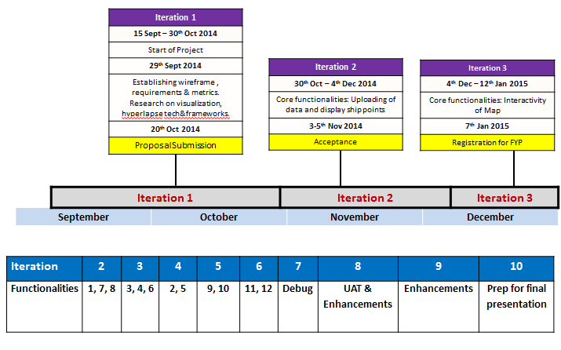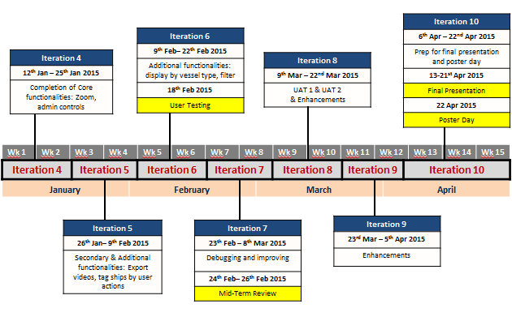

**6 Risks & Contingency Plans:**

|  |  |  |
| --- | --- | --- |
| **Type of Risk** | **Description of Risk** | **Mitigation Plan** |
| **Technical Risk** | Insufficient lead time allowed for learning new technologies | Peer learning , using google to research on technical aspect before starting on coding |
| **Resource Risk** | Application may require upgrading of plans to account for more intensive resources –MongoDB, AWS etc | Ensure client is ready to support additional resource requirements, plan to use these additional resources as late as possible (if expenses is an issue) |
| **Technical Risk** | Late decision to move to a new tool or technology because it seems attractive | Research on viable technologies early , list alternatives , compare and stick to the chosen technologies |

**7 Resources and reference:**

|  |  |
| --- | --- |
| **Description of Technology** | Our team will be developing this application mainly using Javascript and JQuery (front end) and NodeJS (back-end). As our project has large amounts of data to handle, we will be utilizing a MongoDB as our database. Versioning control is done through using GitHub. For the interactivity of the map and visualization of data, we will be looking into D3 and ceisiumJS. |
| **References** | D3, <http://d3js.org/>, <http://www.codecademy.com/courses/web-beginner-en-kcP9b/0/1>  Google Maps Api, <https://developers.google.com/maps/documentation/javascript/>  Google Earth Engine  Ceisiumjs.org  Amazon Web Services  GitHub  MongoDB |
| **Supervisor Meeting** |  |
| **Client Meeting** | Every Monday Morning – 1-2 times a month |
| **Internal Meeting** | 1-2 times a week |